Design Non-relational Storage Case Study

Estimated time: 60 minutes

Requirements  
Tailwind Traders wants to reduce storage costs by reducing duplicate content and, whenever applicable, migrating it to the cloud. They would like a solution that centralizes maintenance while still providing world-wide access for customers who browse media files and marketing literature. Additionally, they would like to address the storage of company data files.

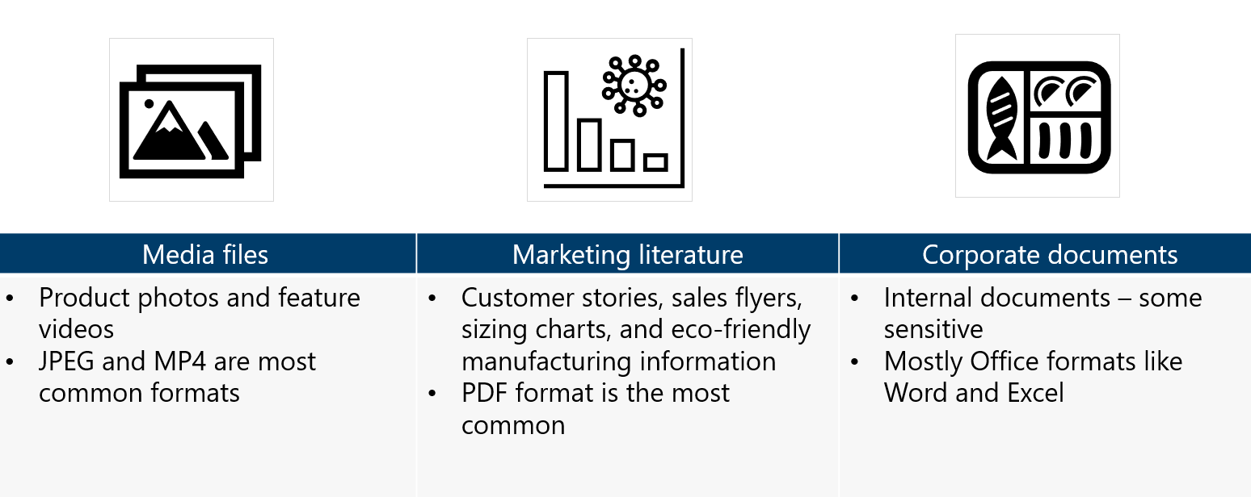

* **Media files**. Media files include product photos and feature videos that are displayed  
  on the company’s public website, which is developed and maintained in house. When a customer browses to an item, the corresponding media files are displayed. The media files are in different formats, but JPEG and MP4 are the most common.
* **Marketing literature.** The marketing literature includes customer stories, sales flyers, sizing charts, and eco-friendly manufacturing information. Internal marketing users access the literature via a mapped drive on their Windows workstations. Customers access the literature directly from the company’s public website.
* **Corporate documents.** These are internal documents for departments such as human resources and finance. These documents are accessed and managed via an internally developed web application. Legal requires that various documents be retained for a specific period of time. Occasionally documents will need to be maintained longer when legal or HR issues are being investigated. Most corporate documents older than one year are only kept for compliance reasons and are seldom accessed.
* **File location.** All the files are stored locally in the main office data center. There are  
  numerous file shares organized by department or product line. The data servers are  
  struggling to provide files for the website. During peak hours website pages are slow to render.
* **File access frequency.** Some products are more popular, and that data is accessed more frequently. However, some products, like ski gear, are only accessed during that season. Sales events generate a lot of interest in certain on sale items.

Tasks

1. Design a storage solution for Tailwind Traders.  
   • What type of data is represented?  
   • What factors will you consider in your design?  
   • Will you use blob access tiers?  
   • Will you use immutable storage?  
   • How will the content be securely accessed?
2. Your solution should consider the media, marketing literature, and corporate  
   documents. Your recommendations may be different depending on the data. Be  
   prepared to discuss your decisions.

**Your Solutions:**